IMP points related to API testing :

1. Cookie based authentication : Once we login to jira through API, we get a session cookie. Then we use that session cookie to make all rest of the API calls for authentication purpose. Once we login, it creates a key for us and we need to use that session’s session key for next all operations in order to continue that session and authentication as well. Use it in header section > as cookie

So, once we login using API(POST) it creates a session, we use that session id in all next API calls.

IMP : To handle this, we use sessionFilter to continue session throughout the execution

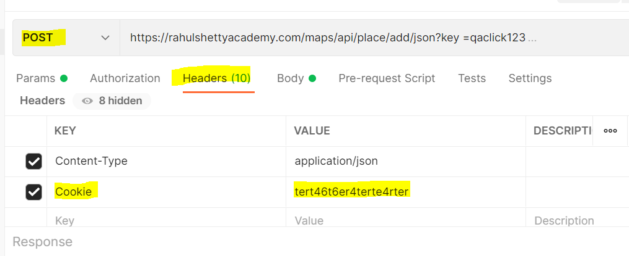

1. Query Paramater : in endpint URL if you see ? then it uses query parameter
2. Path parameter : in endpoint URL if you see only / / / / and no ? then it uses path parameter
3. For get request we do not have header values
4. We can use query parameter and path parameter in one request as below :
5. // GET
6. String respn = *given*()
7. .filter(ss)
8. .pathParam("key","10001")
9. .queryParam("fields", "comment")//parameter field is mentioned in contract document, menas how to refer a field, and what field to refer is : comment field. So only that field is retrieved by GET()
10. .when()
11. .get("/rest/api/2/issue/{key}")
12. .then()
13. .extract().response().asString();
14. System.***out***.println(respn);// it will print entire huge JSON response. but I want to see just if my comment is added or not
15. // for that we use query parameter on line#61

6. *given*().relaxedHTTPSValidation()// this bypasses https authentication like required certificates etc.

7.

Question :

1. What are ways to construct request bodies / payload
2. What are different ways to parse / scan json responses
3. How to send attachments in rest assured?
4. What is serialization, deserialization
5. What is your project
6. You work on front end automation or backend automation?
7. What is your role in in?
8. What value addition you achieved in framework?
9. Array in json files []